DMR Code Plug Organizer for California

W6RUF 28 Feb 2020

Regional Maps courtesy of California Office Emergency Services Fire & Rescue

SEE LAST PAGE FOR CONCLUSIONS

1

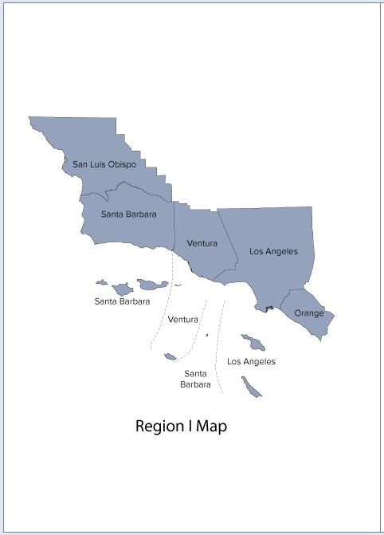

North – SLO and Santa Barbara Counties

South – SoCal Coastal Route, LA Basin, High Level

2

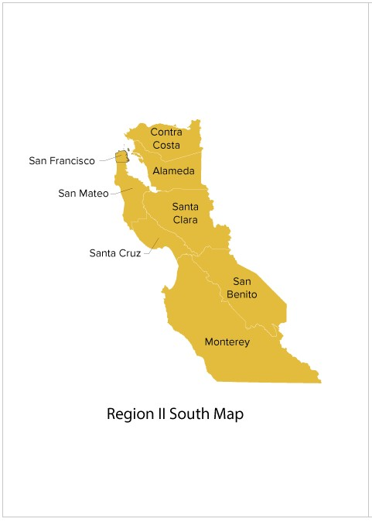

Coastal Route - Del Norte, Humboldt, Mendocino, Lake

Bay Area North – Marin, Sonoma, Napa, Solano

Peninsula – San Francisco, San Mateo, West Contra Costa, West Alameda

Easy Bay – East Contra Costa, East Alameda

South Bay – Santa Clara, Santa Cruz, Monterey, San Benito

3

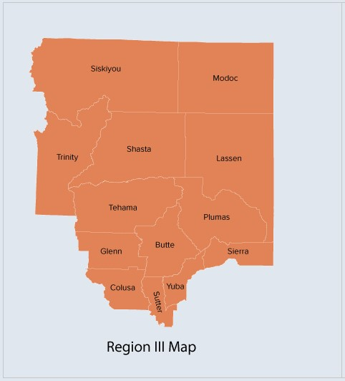

4

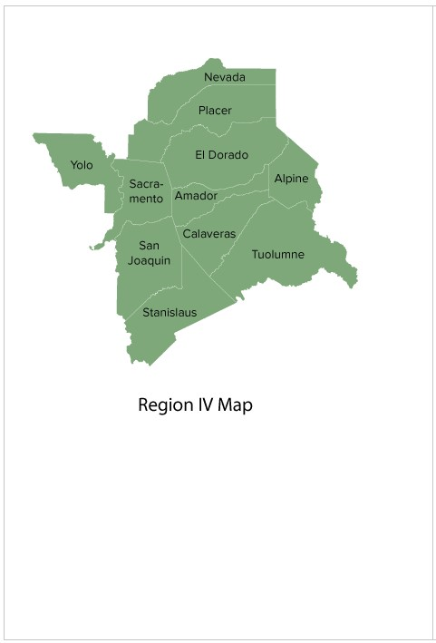

5

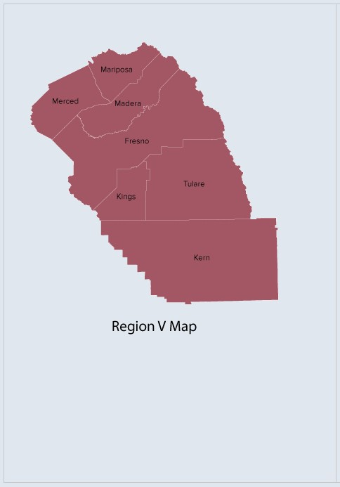

6

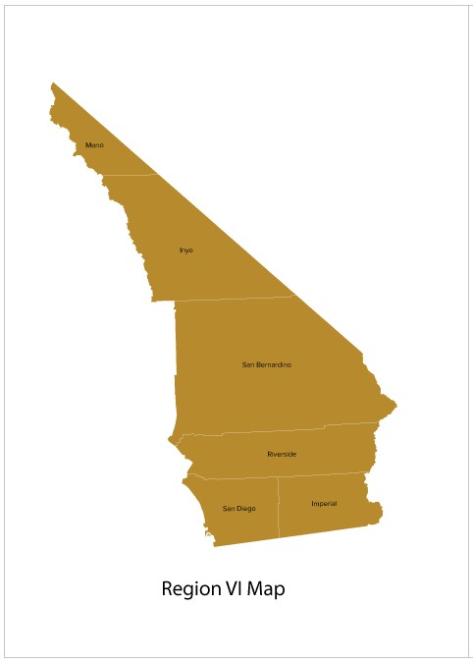

Please note how the San Bernardino & Riverside areas, communications wise, overlaps the LA Basin area which is the southern half of Region I.

**ARRL Pacific Division Nomenclature designating sections by communications coverage.**

* **East Bay** -- Alameda, Contra Costa, Napa, Solano
* **Nevada** – Covers the entire state. See map below
* **Pacific** -- Hawaii and U.S. possessions in the Pacific
* **Sacramento Valley** –
  + **District 1**: Lassen, Modoc, Siskiyou, Trinity
  + **District 2**: Butte, Glenn, Shasta, Tehama
  + **District 3**: Colusa, Sacramento, Sutter, Yolo, Yuba
  + **District 4**: Nevada, Plumas, Sierra
  + **District 5**: Alpine, Amador, El Dorado, Placer
* **San Francisco** -- Del Norte, Humboldt, Lake, Marin, Mendocino, San Francisco, Sonoma
* **San Joaquin Valley** -- Calaveras, Fresno, Kern, Kings, Madera, Mariposa, Merced, Mono, San Joaquin, Stanislaus, Tulare, Tuolumne
* **Santa Clara Valley** -- Monterey, San Benito, San Mateo, Santa Clara, Santa Cruz

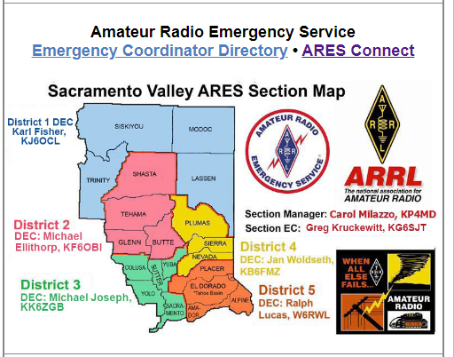

Nice map from the Sacramento Valley Group – seems they got da chit togeda

**ARRL Southwestern Division**

* **Arizona**
* **Los Angeles**
* **Orange** – Inyo, Orange, Riverside and San Bernardino
* **San Diego** – Imperial and San Diego
* **Santa Barbara** – San Luis Obispo, Santa Barbara and Ventura

**Map of Nevada State DMR Repeaters** (repeaterbook.com)

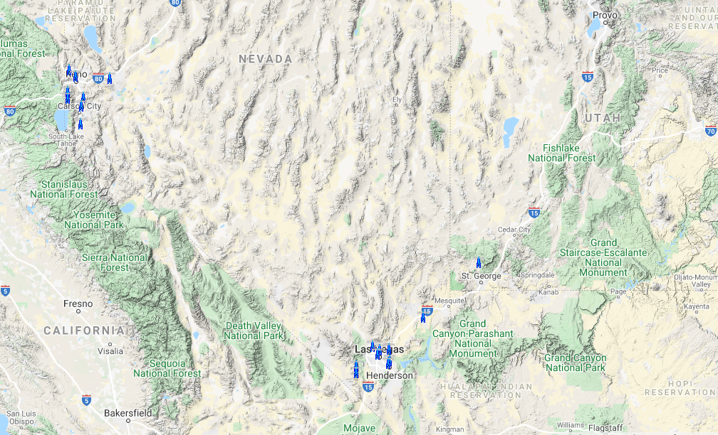

Nevada – Reno Tahoe

Nevada – Vegas

Nevada – Elko

Nevada – Grand Canyon

CONCLUSIONS as of 28 Feb 2020

Well after looking at the way CAL-OES sorted everything, it became problematic to sort using their Regions for three reasons:

1 - Bay Area Region II (map does not show northern counties) contains allot of repeaters and I was going to have to create sub-regions to sort areas by travel corridors.

2 – The Central Valley and Foothills (Regions IV & V) actually overlap when you look at this from a communications standpoint. Same communications coverage area was going to designate repeaters in two Regions.

3 – Having driven through the LA Basin area and using 2 meters, many high level repeaters cover the entire area including hitting the Channel Islands. Region VI (San Bernardino & Riverside) from a communications standpoint, overlaps the southern portion of Region I which is Los Angeles and Orange counties. Again same problem, sorting using CAL-OES Regional designations is problematic.

Using the ARRL Section nomenclature make more sense. We already intuitively know them by geographic areas.

I created a spreadsheet of DMR repeaters from repeaterbook.com and sorted them by county. Then I added columns to sort them via both OES regions (see column B by region and column C I tried adding to sort by travel area), and Column D which uses the ARRL nomenclature.

I think using the ARRL Section Areas designation is a better way to go. So now the Issue becomes: How do we mnemonically designate the ARRL Sectional areas so we can see them on the tiny ass Anytone Display without using a ton of characters. See spreadsheet.

References:

<http://www.arrl.org/section-boundaries>

END OF DOCUMENT